**Homework 12**

**ECE 309 Fall 2019**

**Due: November 25, 2019 (free 48-hour extension)**

Upload an electronic copy of your answers to Moodle under HW12.

*This is a shared google document. This means (1) it may change to clarify content, and (2) other people can view your comments on this file. If you have questions, you are encouraged to comment directly on this document, but* ***do not add your answers here****. Make a copy into your private Google Drive and then edit the document.*

*DO NOT ADD ANSWERS TO THE SHARED DOC! THAT’S CONSIDERED CHEATING!*

# 1. Topological Sort of Directed Graph

[30 points] Consider the following graph. (Disclaimer: all curriculums shown in this problem are purely fictional.)

1. [5 points] Explain the meaning of topological sort in your own words.
2. [15 points] Perform pre-order and post-order traversal of the graph starting at node ECE 109.
3. [10 points] Show two different topological sorts for the graph.

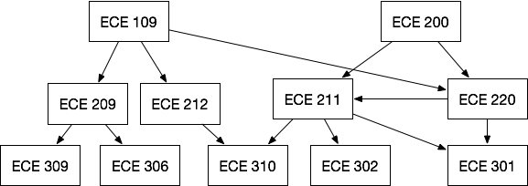

# 2. Shortest Path

[20 points] Find the shortest path from Raleigh to all other nodes in the following weighted graph using Dijkstra’s algorithm. Show your work by filling in the table below. Then, list the shortest path from Raleigh to all other nodes.

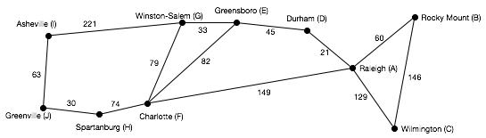

|  |  |  |  |  |  |  |  |  |  |  |
| --- | --- | --- | --- | --- | --- | --- | --- | --- | --- | --- |
| **Next**  **Node** | **A** | **B** | **C** | **D** | **E** | **F** | **G** | **H** | **I** | **J** |
|  | **0** | **inf** | **inf** | **inf** | **inf** | **inf** | **inf** | **inf** | **inf** | **inf** |
|  |  |  |  |  |  |  |  |  |  |  |
|  |  |  |  |  |  |  |  |  |  |  |
|  |  |  |  |  |  |  |  |  |  |  |
|  |  |  |  |  |  |  |  |  |  |  |
|  |  |  |  |  |  |  |  |  |  |  |
|  |  |  |  |  |  |  |  |  |  |  |
|  |  |  |  |  |  |  |  |  |  |  |
|  |  |  |  |  |  |  |  |  |  |  |
|  |  |  |  |  |  |  |  |  |  |  |

|  |  |  |
| --- | --- | --- |
| **From** | **To** | **Path** |
| A | B |  |
| A | C |  |
| A | D |  |
| A | E |  |
| A | F |  |
| A | G |  |
| A | H |  |
| A | I |  |
| A | J |  |

# 3. Minimum Spanning Tree

[25 points] Determine the minimum spanning tree (MST) for the following weighted graph. Show each step of the algorithm. Then, redraw the graph showing only the MST.

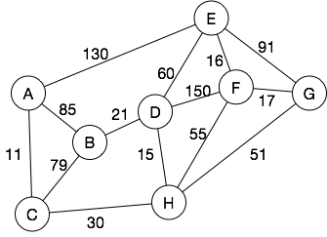

|  |  |  |
| --- | --- | --- |
| Next Edge | Add to MST? | Vertex Sets |
|  |  |  |
|  |  |  |
|  |  |  |
|  |  |  |
|  |  |  |
|  |  |  |
|  |  |  |
|  |  |  |

# 4. ZyLab

* [25 points] ZyLab 19.15. Implement a minimum spanning tree algorithm on the provided data structures in the ZyLab.
  + 20 points: pass the tests in ZyLab.
  + 5 points: Your code must run in no worse than O(E*V). Note, this gives you the option of using relatively inefficient but easier to program operations.